**Weekly Assessment – DevOps**

**Task Allocation with Kubernetes and Infrastructure as Code (IaC):**

**Task 1:** Explain how to identify the need for scaling based on traffic metrics or other indicators.

**Answer:** Identifying the need for scaling in a Kubernetes cluster is crucial for efficient application performance. This includes identifying the need for scaling, updating Terraform code, and guidelines for testing and deployment with real-time configuration examples. We can efficiently allocate the task of scaling based on traffic metrics or indicator by following series of steps.

* First, we (team) must Identify the need for scaling based on the increased traffic and the next step would be defining the requirement.
* For this task we can use monitoring tools like Prometheus, AWS Cloudwatch, Netdata, InfluxDB and Grafana to collect metrics such as CPU utilization, memory usage, request rates, and response times.
* Now what we do is to define thresholds for key metrics. For example, if CPU utilization consistently exceeds 80% or request rates spike significantly, it's a sign that scaling may be necessary.
* For this we should configure alerting rules in Prometheus or other monitoring systems to trigger notifications when thresholds are breached.

* Later we will analyze historical data to identify recurring patterns, such as traffic spikes during specific hours or days and based on this the monitoring tools will trigger an alert where scaling will be automated based on the threshoulds set for key metrics.

**Task 2:** Describe the process of creating or updating Terraform code to adjust the desired replica count of the application.

**Answer:**

* in this task what we do isto adjust the desired replica count of the application using Terraform, we will typically manage this through Kubernetes Deployment resources.
* Here in the below example we update the ‘replicas’ field within the ‘kubernetes_deployment ’ resource block to set the desired number of replicas.
* Later we Run ‘terraform init’ and ‘terraform plan’ / ‘terraform apply’ to creat / apply the changes to your Kubernetes cluster.

**Example:**

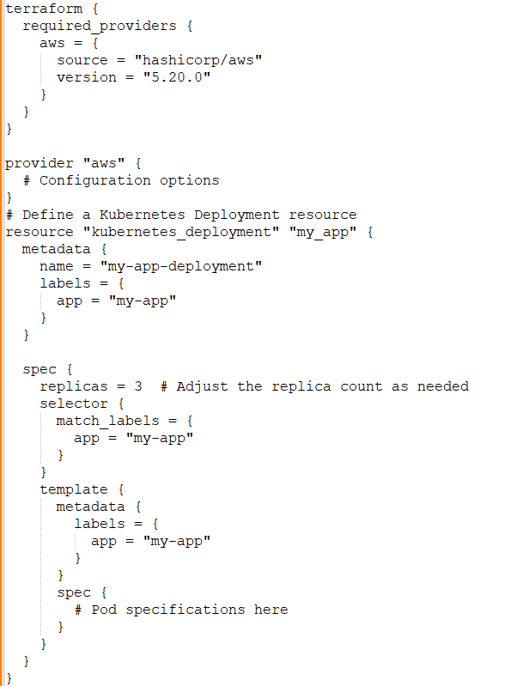

**Task 3:** Provide guidelines for testing the scaling changes and deploying them to the Kubernetes cluster while minimizing downtime.

**Answer:** here to test scaling changes and deploy them with minimal downtime, we need to follow some series of steps.

* We shall Set up a staging environment that mirrors your production environment for testing and implement automated tests to validate the scaling changes locally to ensure they function as expected.
* Here we will utilize Kubernetes Horizontal Pod Autoscaler (HPA) to enable automatic scaling based on metrics.

**Example:**

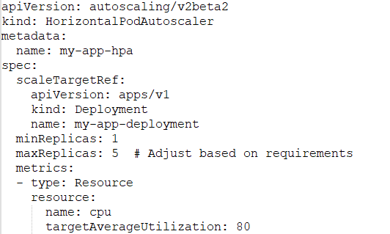

* We shall use the Kubernetes' built-in rolling update strategy when deploying changes.

**Example:**



* Now we shall continuously monitor the application's health, performance, and error rates during and after the deployment.
* While using strategies like Blue-Green deployments or Canary releases we can minimize downtime when deploying scaling changes.
* By following these series of steps and configuring our Terraform and Kubernetes resources accordingly, we can efficiently scale your application based on increased traffic while maintaining high availability and minimizing disruption.

**Optional:**

Creating a complete Terraform script for managing a Kubernetes Deployment and Horizontal Pod Autoscaler (HPA) with efficient scaling and monitoring is quite extensive. However, I'll provide a simplified example to demonstrate how to use Terraform for managing these Kubernetes resources.

* We define a Kubernetes Deployment for "my-app" with 3 replicas and a container based on the image "my-image:latest".
* We create a Horizontal Pod Autoscaler (HPA) for "my-app" with a target average CPU utilization of 80%, scaling between 1 and 5 replicas.
* In this example, we'll define a Kubernetes Deployment and HPA for a hypothetical "my-app".

**Example:**

